**ADAILY ONLINE ACTIVITIES SUMMARY**

|  |  |  |  |  |  |  |  |
| --- | --- | --- | --- | --- | --- | --- | --- |
| **Date:** | **15/06/2020** | | | | **Name:** | **Anusha. K** | |
| **Sem & Sec** | **4th SEM 'A' Section** | | | | **USN:** | **4AL18CS009** | |
| **Online Test Summary** | | | | | | | |
| **Subject** | | **No test** | | | | | |
| **Max. Marks** | | **-** | | **Score** | | **-** | |
| **Certification Course Summary** | | | | | | | |
| **Course** | **Introduction to programming** | | | | | | |
| **Certificate Provider** | | | **greatlearning academy** | **Duration** | | | **5.5 hours** |
| **Coding Challenges** | | | | | | | |
| **Problem statement 1:Write a Java Program to find if string is K-Palindrome or not.**  **Problem statement 2:Write a C Program to perform the following operations on Triply Linked List (TLL)**  **Problem statement 3:Write a C Program to implement the Binary Reversal.** | | | | | | | |
| **Status: completed** | | | | | | | |
| **Uploaded the report in Github** | | | | **yes** | | | |
| **If yes Repository name** | | | | [**https://github.com/anusha20219/Lockdown-coding**](https://github.com/anusha20219/Lockdown-coding) | | | |
| **Uploaded the report in slack** | | | | **yes** | | | |

ONLINE TEST DETAILS: No test

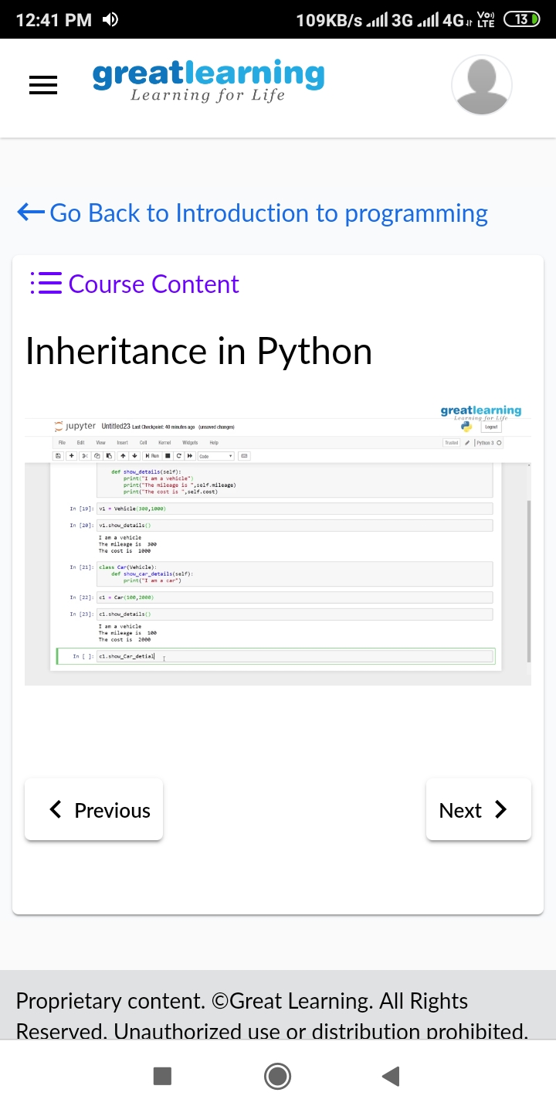CERTIFICATION COURSE DETAILS: Today I began with introduction to programming certification course where I studied the topics python pandas and matplotlib. Pandas dataframe, functions, line plot, bar plot, scatter plot.

Coding challenge details:

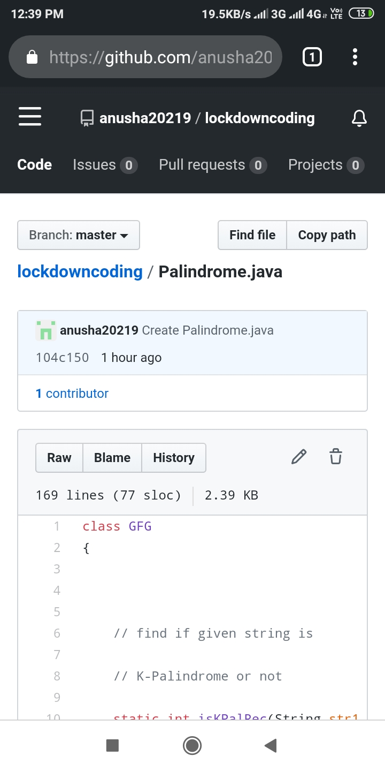statement 01:Write a Java Program to find if string is K-Palindrome or not.

Problem statement 2:Write a C Program to perform the following operations on Triply Linked List (TLL).

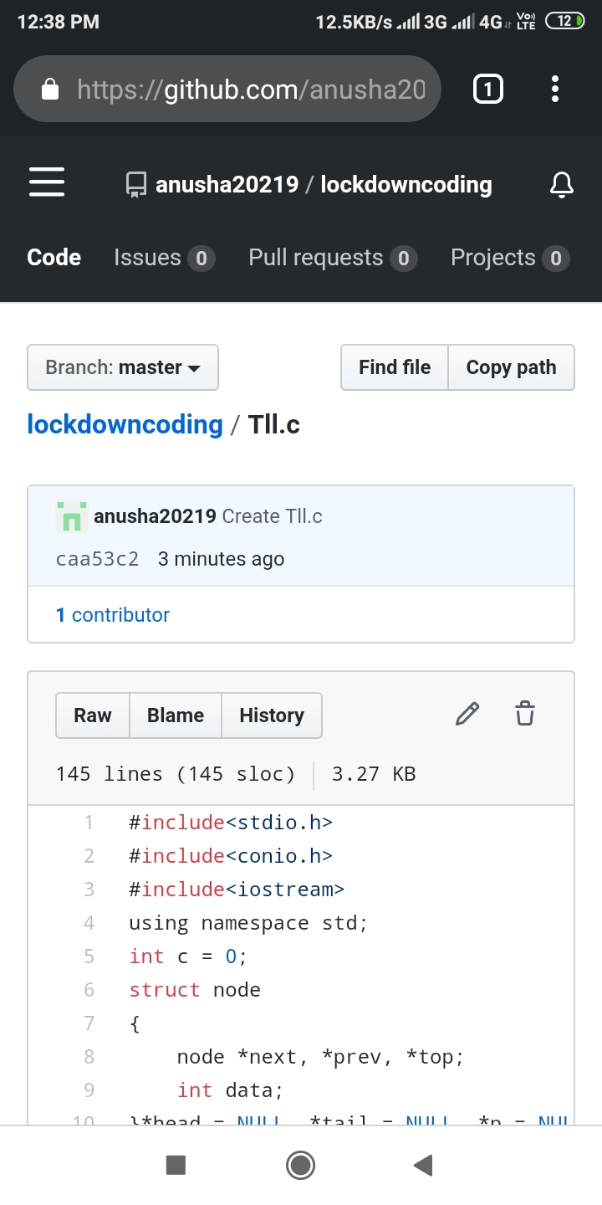

Problem statement 3: Write a C Program to implement the Binary Reversal.

